CDA Generation and Integration for Health Information Exchange Based on Cloud Computing System
ABSTRACT:
Successful deployment of Electronic Health Record helps improve patient safety and quality of care, but it has the prerequisite of interoperability between Health Information Exchange at different hospitals. The Clinical Document Architecture (CDA) developed by HL7 is a core document standard to ensure such interoperability, and propagation of this document format is critical for interoperability. Unfortunately, hospitals are reluctant to adopt interoperable HIS due to its deployment cost except for in a handful countries. A problem arises even when more hospitals start using the CDA document format because the data scattered in different documents are hard to manage. In this paper, we describe our CDA document generation and integration Open API service based on cloud computing, through which hospitals are enabled to conveniently generate CDA documents without having to purchase proprietary software. Our CDA document integration system integrates multiple CDA documents per patient into a single CDA document and physicians and patients can browse the clinical data in chronological order. Our system of CDA document generation and integration is based on cloud computing and the service is offered in Open API. Developers using different platforms thus can use our system to enhance interoperability.
EXISTING SYSTEM:
- Effective health information exchange needs to be standardized for interoperable health information exchange between hospitals. Especially, clinical document standardization lies at the core of guaranteeing interoperability.
- It takes increasing amount of time for the medical personnel as the amount of exchanged CDA document increases because more documents means that data are distributed in different documents. This significantly delays the medical personnel in making decisions. Hence, when all of the CDA documents are integrated into a single document, the medical personnel is empowered to review the patient’s clinical history conveniently in chronological order per clinical section and the follow-up care service can be delivered more effectively. Unfortunately for now, a solution that integrates multiple CDA documents into one does not exist yet to the best of our knowledge and there is a practical limitation for individual hospitals to develop and implement a CDA document integration technology.

DISADVANTAGES OF EXISTING SYSTEM:
- The HIS development platforms for hospitals vary so greatly that generation of CDA documents in each hospital invariably requires a separate CDA generation system. Also, hospitals are very reluctant to adopt a new system unless it is absolutely necessary for provision of care. As a result, the adoption rate of EHR is very low except for in a few handful countries.
- Unfortunately for now, a solution that integrates multiple CDA documents into one does not exist yet to the best of our knowledge and there is a practical limitation for individual hospitals to develop and implement a CDA document integration technology.
- To establish confidence in HIE interoperability, more HIS’s need to support CDA. However, the structure of CDA is very complex and the production of correct CDA document is hard to achieve without deep understanding of the CDA standard and sufficient experience with it.
PROPOSED SYSTEM:
- In this paper we present (1) a CDA document generation system that generates CDA documents on different developing platforms and (2) a CDA document integration system that integrates multiple CDA documents scattered in different hospitals for each patient.
- CDA Generation API generates CDA documents on cloud.
- CDA Generation Interface uses the API provided by the cloud and relays the input data and receives
- CDA documents generated in the cloud.
- Template Manager is responsible for managing the CDA documents generated in the cloud server. Our system uses CCD document templates.
- CDA Generator collects patient data from hospitals and generates CDA documents in the template formats as suggested by the Template Manager.
- CDA Validator inspects whether the generated CDA document complies with the CDA schema standard.
ADVANTAGES OF PROPOSED SYSTEM:
- Hospital systems can simply extend their existing system rather than completely replacing it with a new system. Second, it becomes unnecessary for hospitals to train their personnel to generate, integrate, and view standard-compliant CDA documents.
- The cloud CDA generation service produces documents in the CDA format approved by the National Institute of Standards and Technology (NIST).
- If this service is provided for free at low price to hospitals, existing EHR are more likely to consider adoption of CDA in their practices.
- Interoperability between hospitals not only helps improve patient safety and quality of care but also reduce time and resources spent on data format conversion.
SYSTEM ARCHITECTURE:
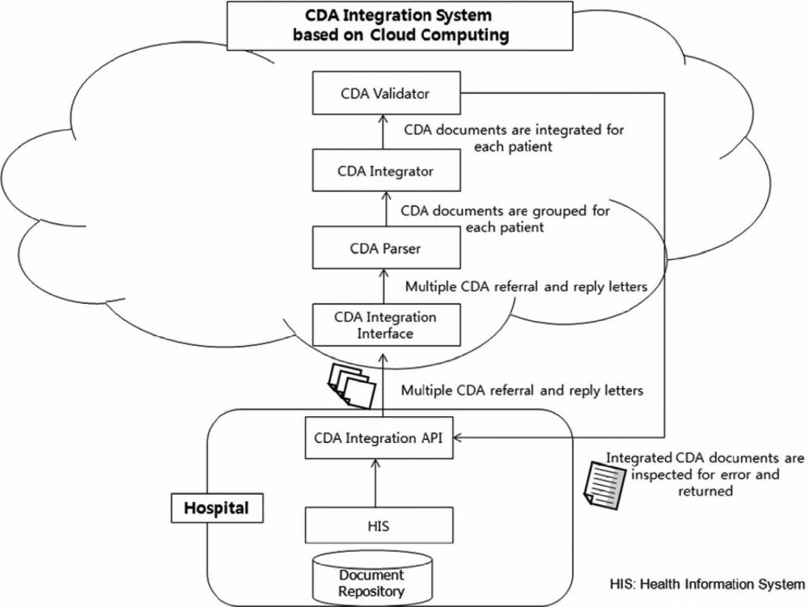
SYSTEM REQUIREMENTS:
HARDWARE REQUIREMENTS:

- System : Pentium Dual Core.
- Hard Disk : 120 GB.
- Monitor : 15’’ LED
- Input Devices : Keyboard, Mouse
- Ram : 1GB.

SOFTWARE REQUIREMENTS:

- Operating system : Windows 7.
- Coding Language : JAVA/J2EE
- Tool : Netbeans 7.2.1
- Database : MYSQL
REFERENCE:
Sung-Hyun Lee, Joon Hyun Song, and Il Kon Kim, “CDA Generation and Integration for Health Information Exchange Based on Cloud Computing System”, IEEE TRANSACTIONS ON SERVICES COMPUTING, VOL. 9, NO. 2, MARCH/APRIL 2016.

